**Python for Data Science, AI and Development**

1. A type is how python represents different types of data
2. Integers: 11 – integer
   1. Negative and positive numbers
3. Real numbers: 21.213 – float
   1. Numbers inbetween integers (0.1, 0.2, 0.3)
4. Words: “Hello python 101” - string
5. Type-casting: changing the expression in Python
   1. Change integer to a float: float(2):2.0
6. Booleon: True or False
   1. Type(true): Bool
   2. Booleon (true) to an integer = (1)
   3. Booleon (False) we will get a = (0)

**Expressions and Variables**

1. Expressions: Describe a type of operation a computer performs
   1. Mathematical: 43+60+16+41 = 160
   2. Numbers called: Operands
   3. Maths symbols: Operators
   4. Operations in brackets performed first: (30+2)*60 = 1920
2. Variables: Used to store values
   1. My_variable = 1
   2. My_variable:10
   3. X = 160
   4. Then perform operations of “x”: y=x/60… Y=2.666

**String Operations**

1. String is a sequence of characters
2. Contained between two quote: “” // ‘ ‘
3. Can be spaces or digits “1 2 3 4 5 6”
4. Special characters @#$%^
5. String can be indexed
   1. MICHAEL JACKSON  
      01234567891011121314
   2. Name[0]: M
   3. Name[6]: L
   4. Name[13]: O
6. Strings can be Sliced (list or tuple)
   1. Name[0:4] = Mich
   2. Name[8:12] = Jack
   3. Use command “len” to give integer values: len(“Michael Jackson) = 15
   4. Concatenate/Combine: name = Michael Jackson. Statement = Name+”is the best”. Statement = “Michael Jackson is the best”
   5. Tuples: 3 * “Michael Jackson” = Michael Jackson Michael Jackson Michael Jackson
7. Strings can be Stride
   1. Name[::3]: ‘McalJcsn” Every second variable

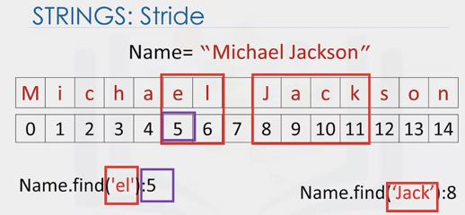

1. Strings are immutable
2. Strings: Escape Sequences
   1. \
   2. Print (“Michael Jackson \n is the best”) = Michael Jackson

Is the best

* 1. \\
  2. Print(“Michael Jackson \t is the best”) = Michael Jackson is the best
  3. Print(“Michael r\ Jackson”) = Michael \ Jackson

1. Method
   1. A = “Thriller”
   2. B = “A.upper()
   3. Result: B=THRILLER
2. Replace
   1. A= ‘Michael Jackson’
   2. B=A.replace(‘Michael’, ‘Janet’)
   3. Result: ‘Janet Jackson’
3. Find
   1. Name.find(‘Jack’) = 8

**Lists and Tuples**

1. Called compound data types

**Tuples**

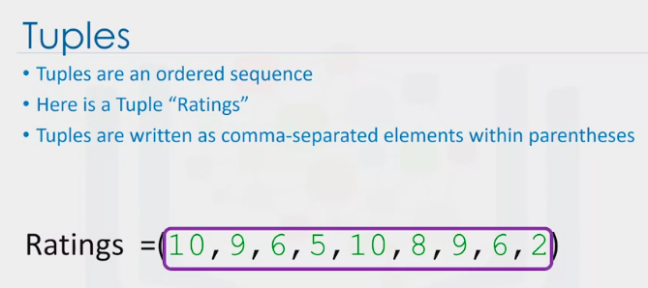

1. Three different types:
   1. Strings: ‘disco’
   2. Int: ‘10’
   3. Float ‘1.2’

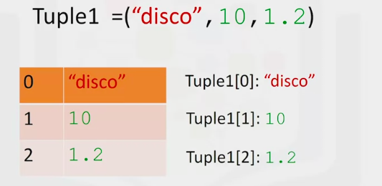

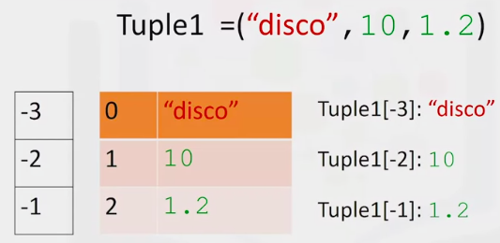

1. Concatenate

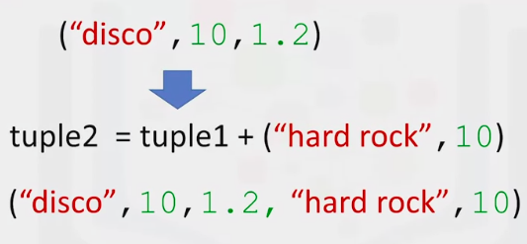

1. Slicing
   1. The number is one larger in the index

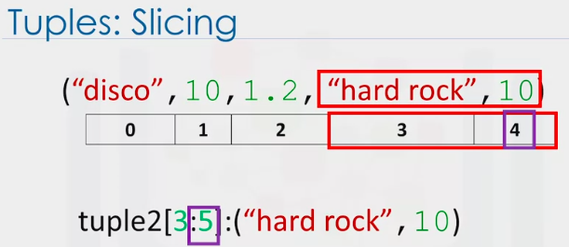

1. Len Command

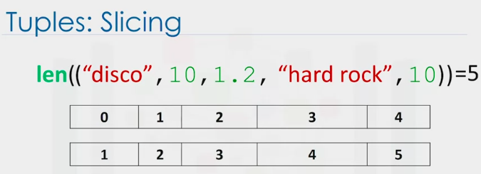

1. Immutable
   1. Cant change a tuple – ratings and ratings1 will be the same

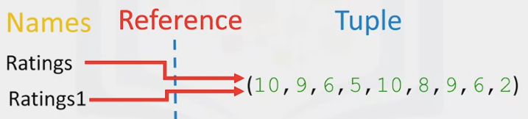

* 1. If we want to sort a tuple we can use the command “sorted” but the tuple remains the same

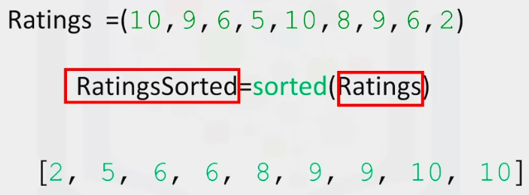

1. Nesting

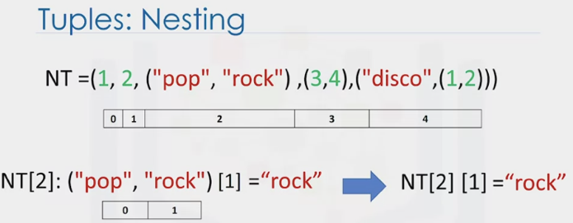

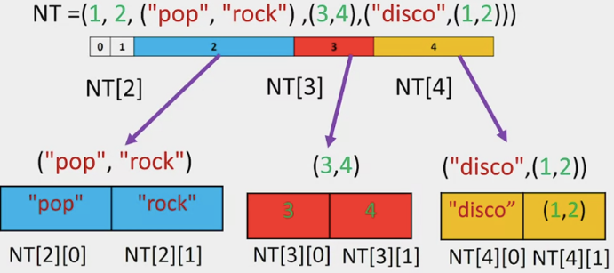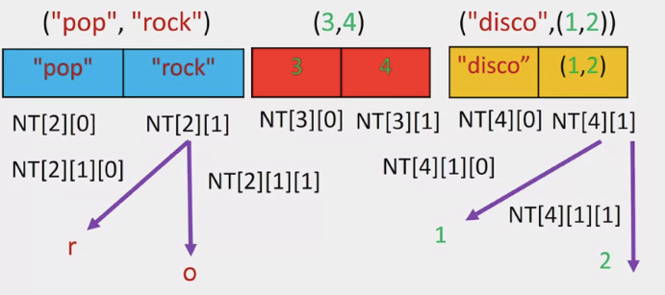

1. Lists
   1. Lists are also ordered sequences
   2. A list is represented with square brackets
   3. Lists are mutable and can contain strings, floats, integers and we can nest other lists

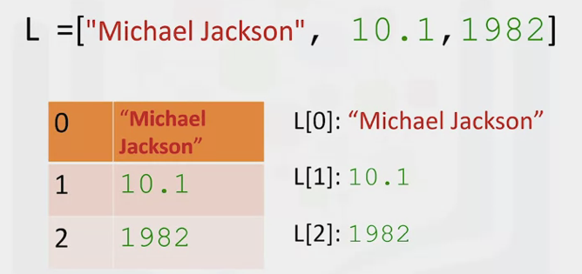

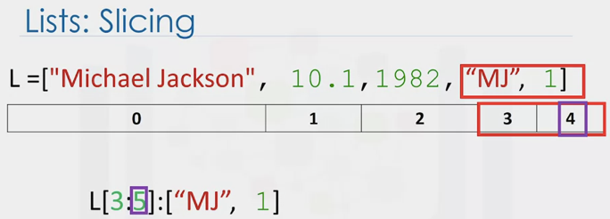

Notice how the last index is 1 larger

1. Concatenate lists or (using “extend”) add to lists

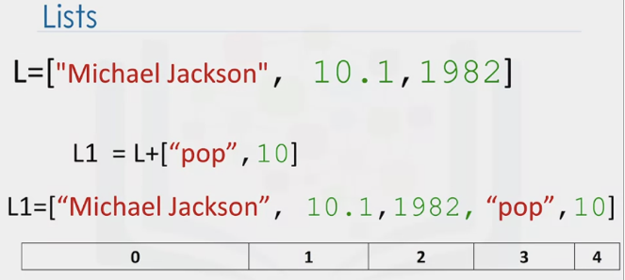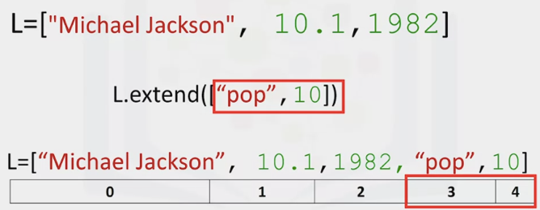

1. Concatenate lists using “append”

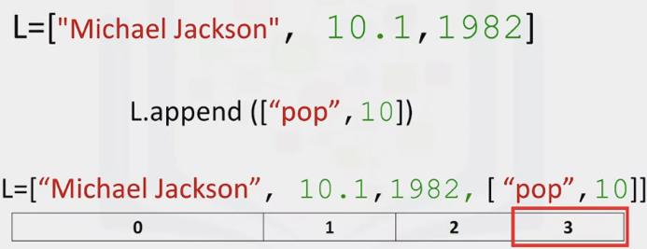

1. Convert String to List using “SPLIT”

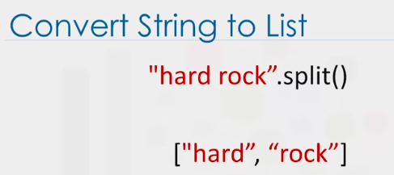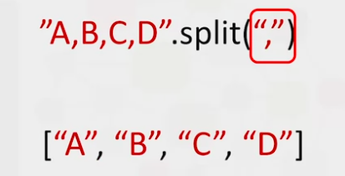

1. Aliasing: Referencing the same list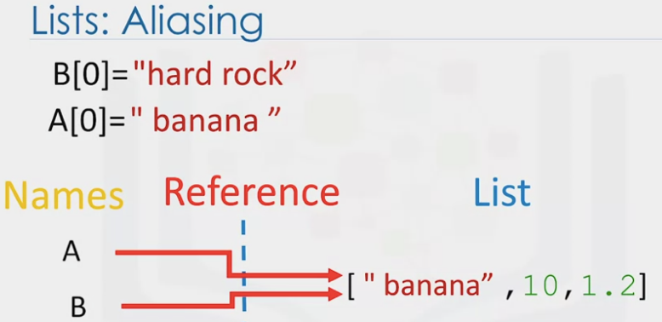
2. Clone a List Using [:]

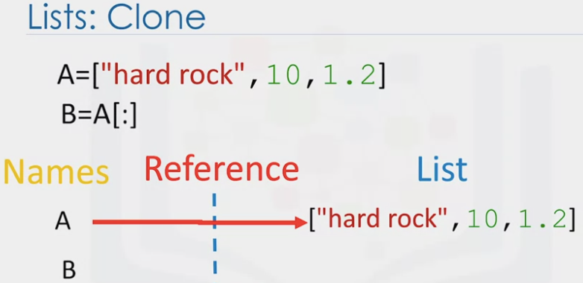

**DICTIONARIES**

1. Type of collection

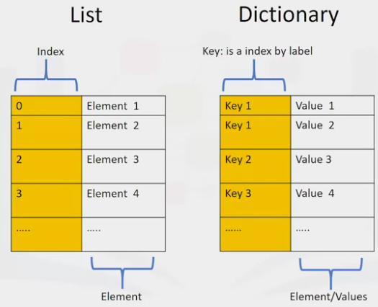

1. Dictionaries are denoted with curly Brackets {}
2. The keys have to be immutable and unique
3. Each key and value pair is separated by a comma





1. Assign the dictionary to a variable

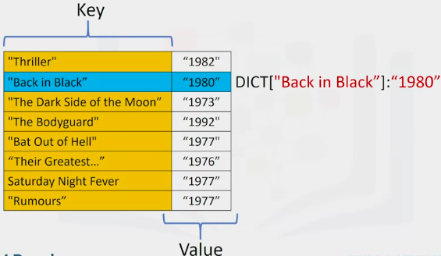

1. Add a new entry: DICT[‘Graduation’]=’2007’
2. Delete an entry: del(DICT[‘Thriller”])
3. IN command checks dictionary for a word
   1. ‘The Bodyguard’ IN DICT = True
4. To select all the keys in a dictions
   1. DICT.keys()=[etc, etc, etc]
   2. DICT.values() = [1982, etc, etc]
5. Each key is separated from its value with a colon

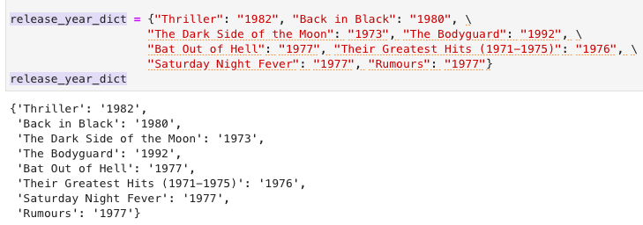

**SETS**

1. Type of collection
   1. Like lists and tuples you can input different Python types
2. Unlike lists and tuples, they are unordered
   1. Sets do not record element position
3. Sets only have unique elements
   1. Only one of a particular element in a set

**Creating a set**



1. When the set is created, duplicate item will not be present

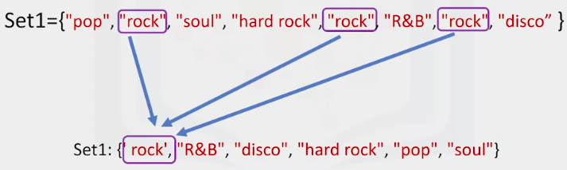

1. Type casting: Creating a set from a list

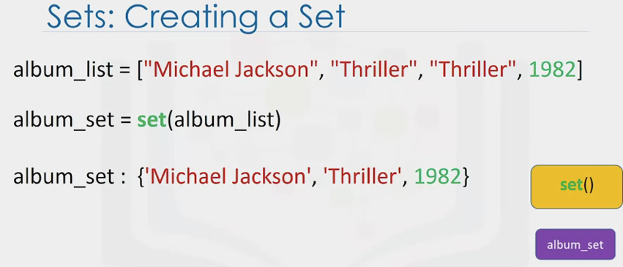

**Operations using sets**

1. Removing an item in a set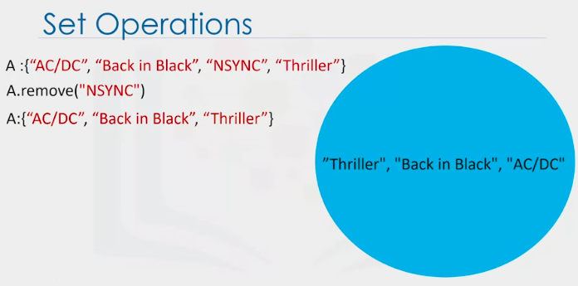
2. Use the IN command to check if an item is in a set
3. Combining sets – removes all elements not in both sets – use &

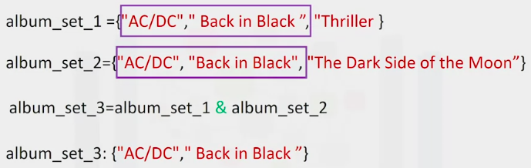

1. Combining Albums without losing data (use the .union command)

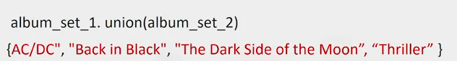

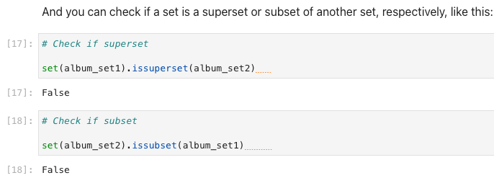  
  
  
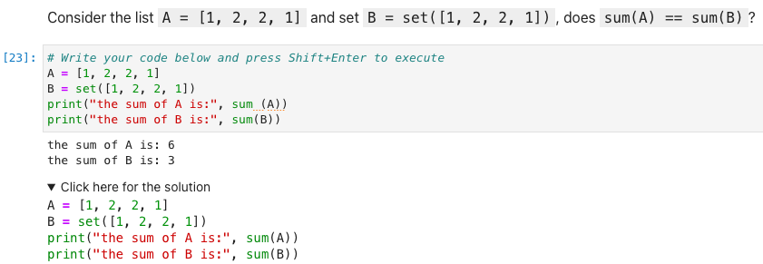

s**CONDITIONS AND BRANCHING**

1. Comparison Operators

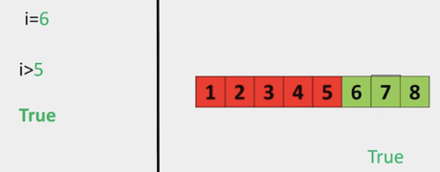 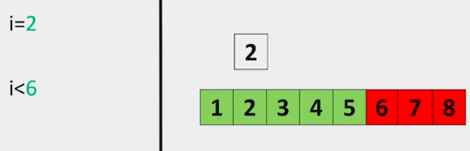

1. Inequality Test n!=

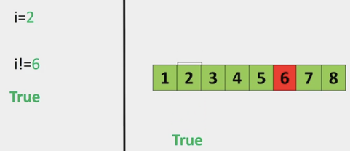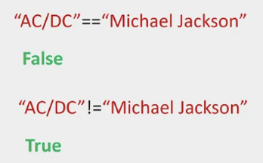

1. If and ELIF Statement

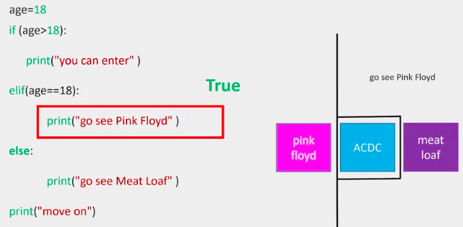

**LOGIC OPERATORS**

1. Take boolean operators and return boolean operators

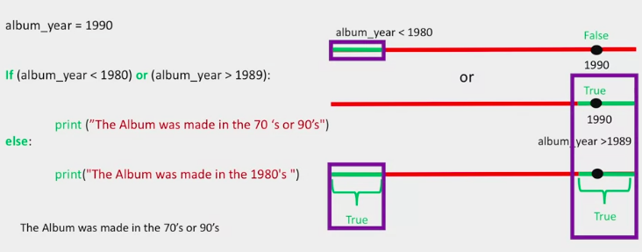

* equal: **==**
* not equal: **!=**
* greater than: **>**
* less than: **<**
* greater than or equal to: **>=**
* less than or equal to: **<=**

**LOOPS**

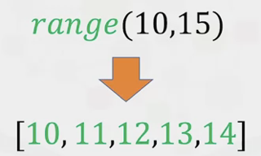

1. FOR LOOPS

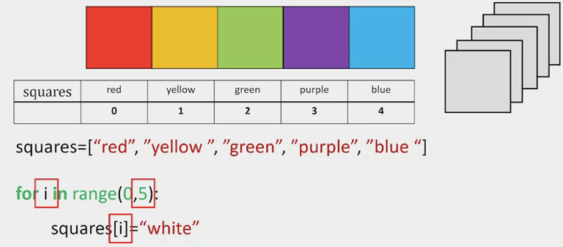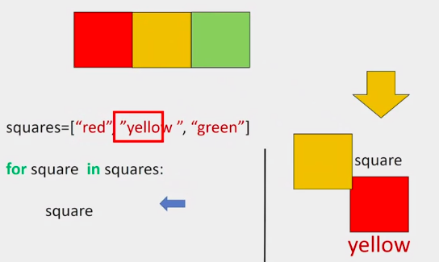

* 1. “Enumerate”

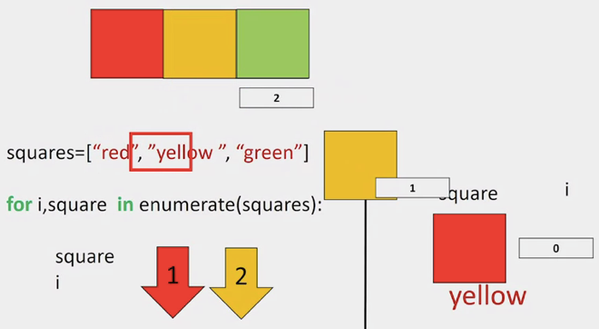

1. WHILE LOOPS
   1. Will only run if a condition is met

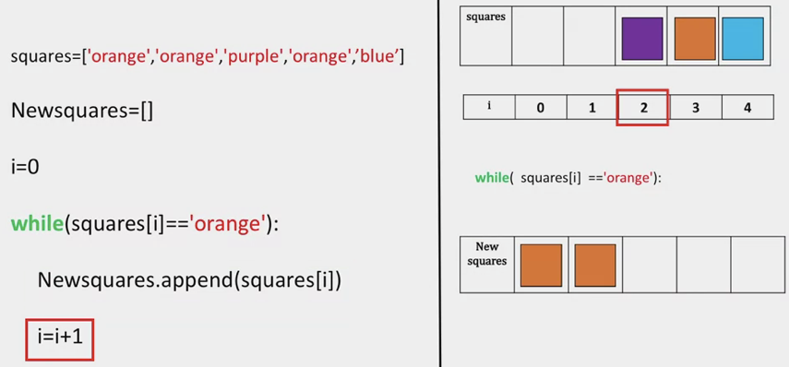

**FUNCTIONS**

1. Line of code you can reuse
2. LEN: Takes an input of type sequence and returns the length of the list
3. SUM: 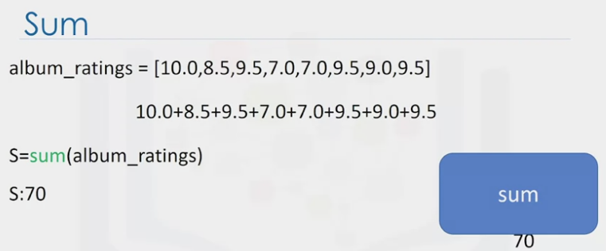
4. SORTED 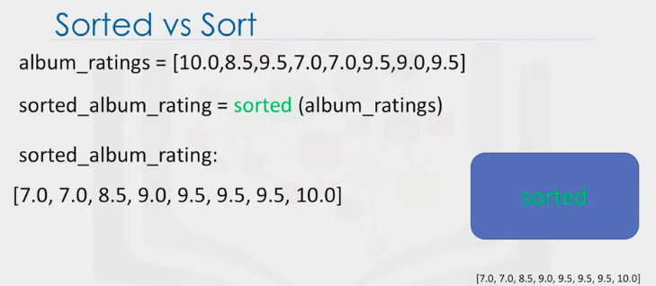
5. SORT 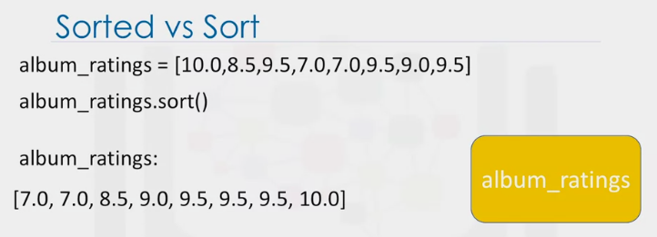
6. CREATING A FUNCTION:

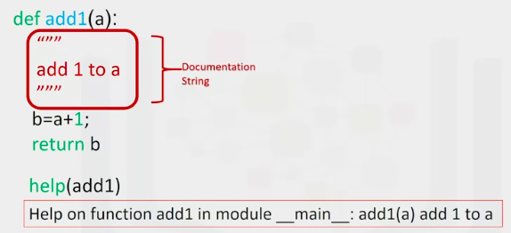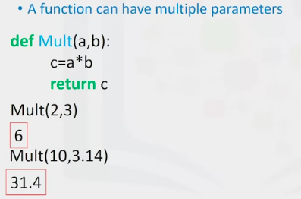

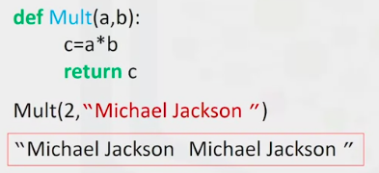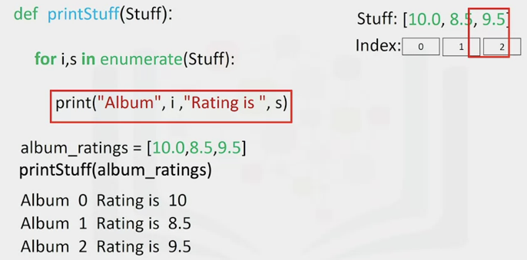

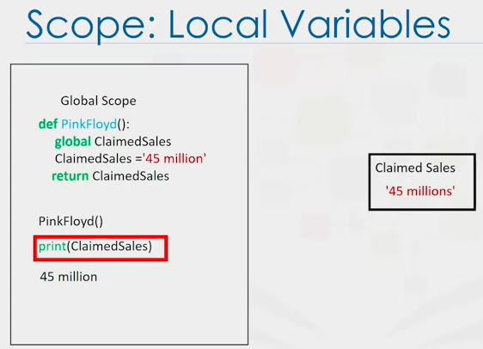

**EXCEPTION HANDLING**

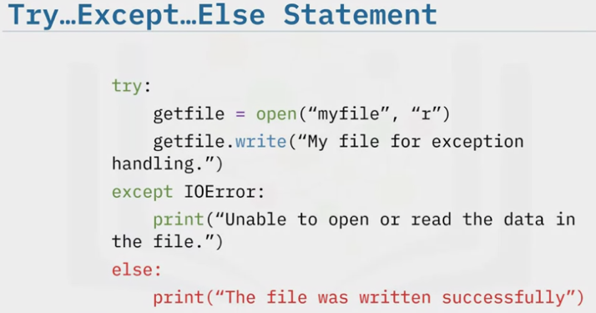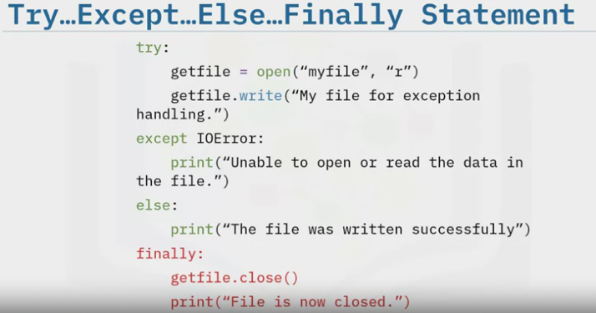

**OBJECTS AND CLASSES**

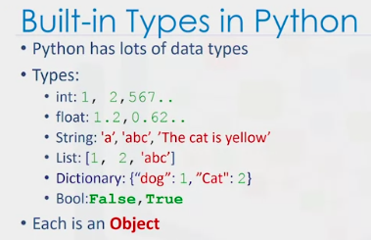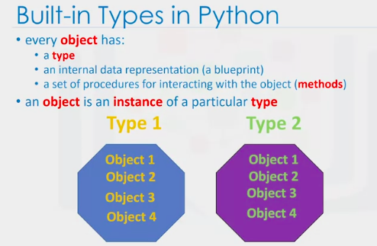

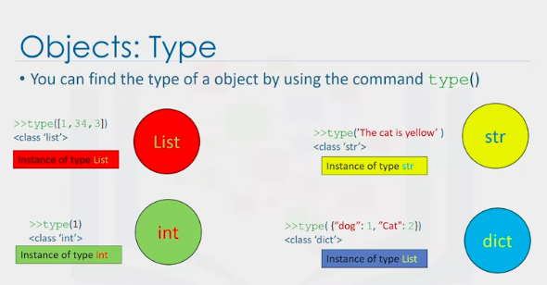

1. Methods
   1. A class or type’s method are functions that every instance of that class or type provides
   2. It is how you interact with the data in an object
   3. Sorting is an example of how you interact with the data in the object
      1. Ratings = [10, 9, 8, 6, 8, 9] – data contained within the object
      2. Ratings.sort() – we call the method by adding a period at the end of the objects name
2. Classes

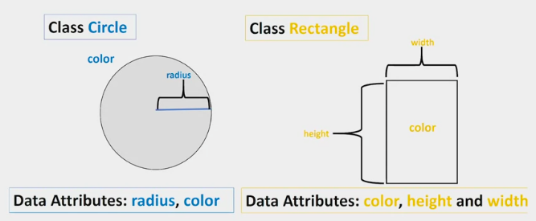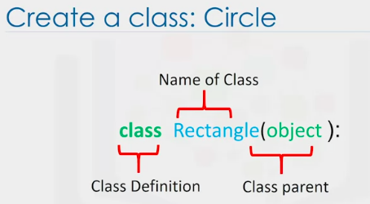

3 Attributes and Objects

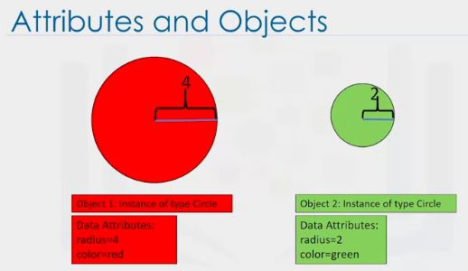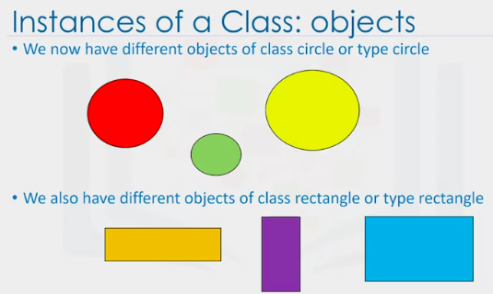

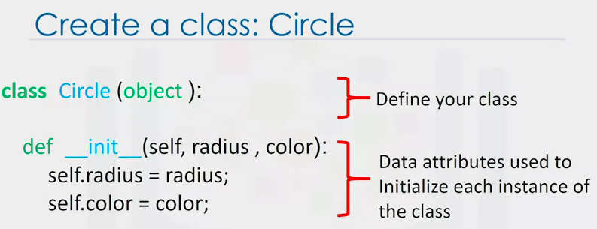

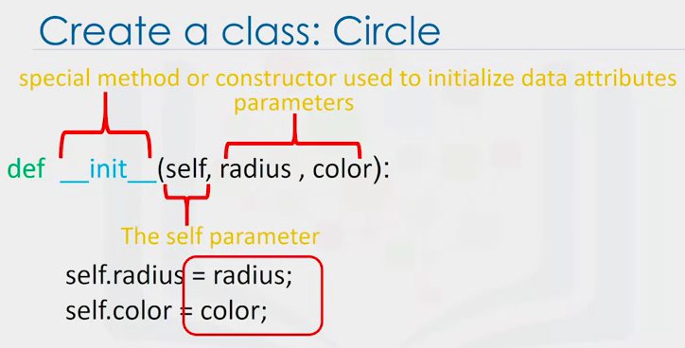

1. INIT: tells python you are making a new class
2. RADIUS and COLOR: Used to initialize the attributes of the class instance
3. SELF: Refers to the newly created instance of the class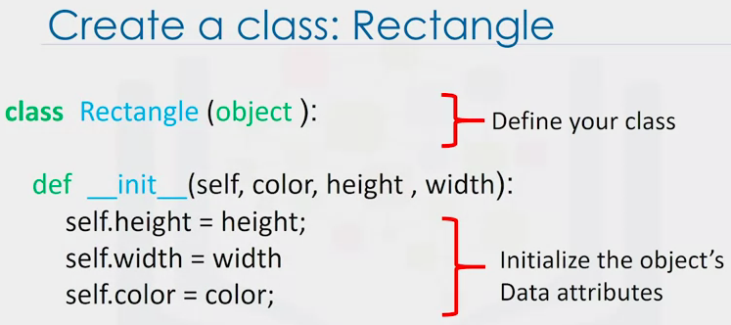

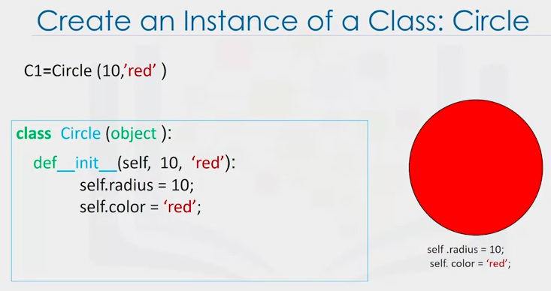

1. METHODS: Functions that interact and change the attributes of the objects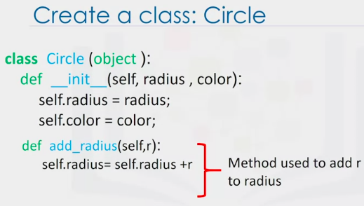
   1. In this case we add the value “r” to the radius

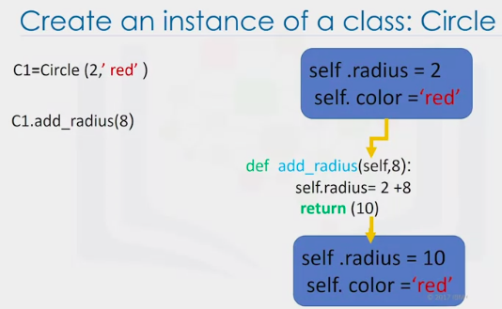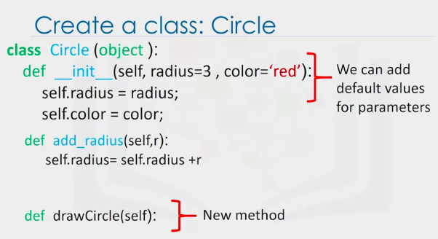

**WEEK 4 – READING FILES WITH OPEN**

1. File1 = open(“/resources/data/Example2.txt”.W”)
   1. Open function
   2. First argument is the file path
   3. Example2.txt = file name
   4. /resources/data/ = file directory
   5. Mode:
      1. R: Reading
      2. W: Writing
      3. A: Appening
   6. File = file object
2. Better practice to use “with” as it automatically closes the file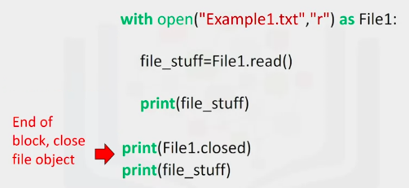
3. Readlines(): Output every element in a list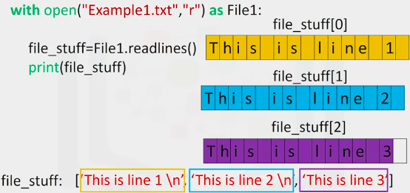
4. Loop: Use a loop to print out each file line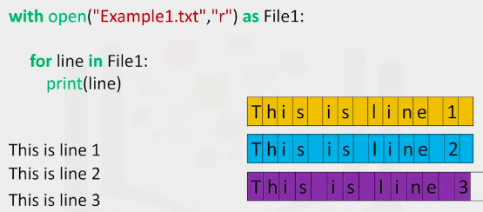
5. Specify each character as an argument with readlines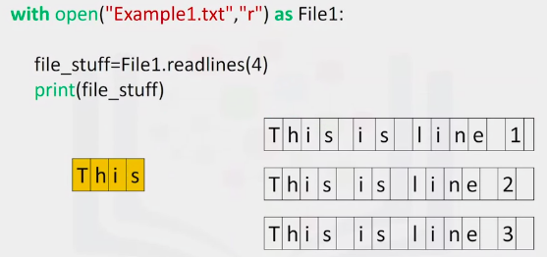
6. The argument () with readlines can be replicated

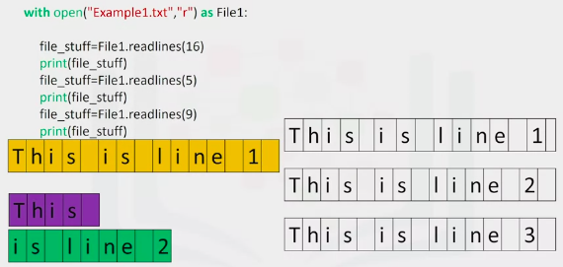

1. Iteration

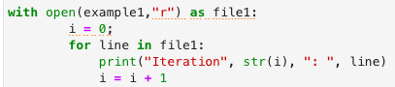

1. Save the text file to a list

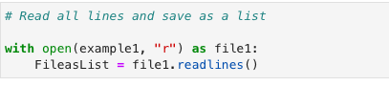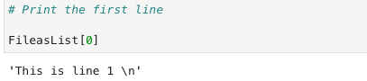

**Writing Files with Open**

1. Creating new files

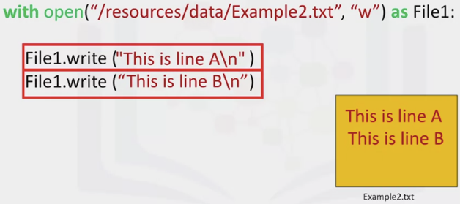

1. Creating new files with a loop

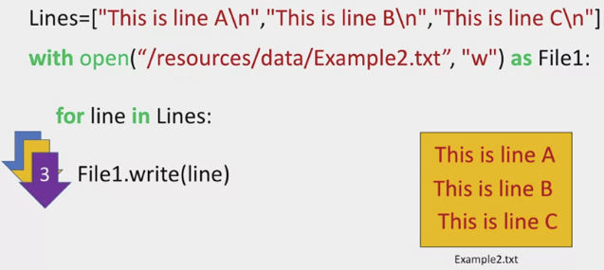

1. Append an existing file

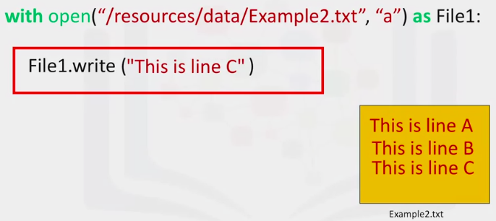

1. Copy one file to a new file

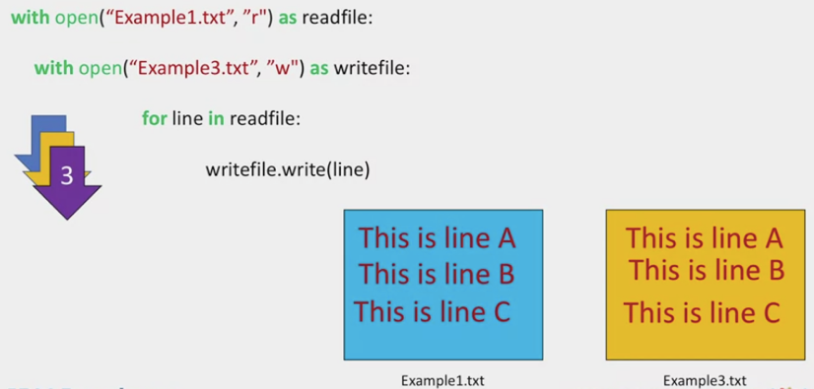

**WEEK 4: LOADING DATA WITH PANDAS**

1. Import pandas as pd

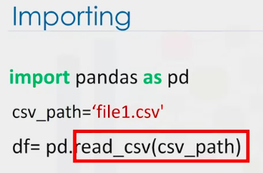

1. Dataframe
   1. Going from a csv file to a dataframe

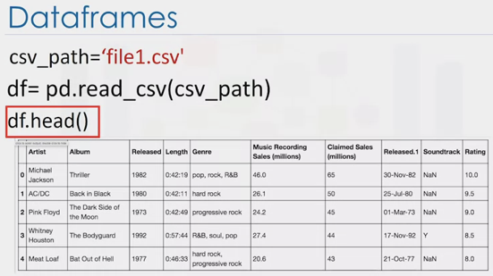

1. Retrieving information from a dataframe

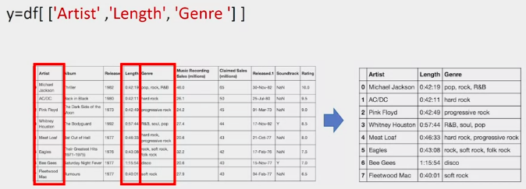

**Working with and saving data**

1. Determining a unique aspect of a dataframe (using the UNIQUE function)

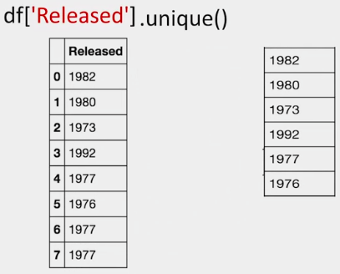

1. Select specified columns with one line of code – creating a new dataframe

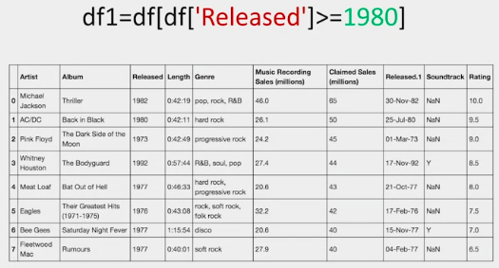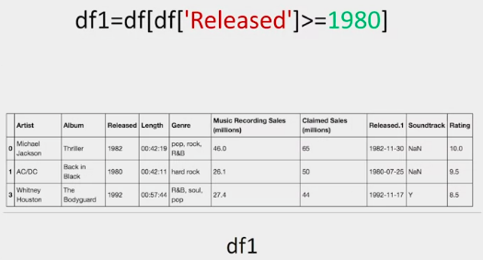

1. Saving the new dataframe
   1. Df1.to_csv(‘new_songs.csv’)

**NUMPY IN PYTHON**

1. Library for scientific computing
2. Basis for Pandas

Basic

1. NP array is similar to a list – each element of the list is of the same type
2. Import numpy as NP
3. A = np.array([0, 1, 2, 3, 4])
   1. A.size :5
   2. A. ndim :1 (number of array dimensions, or the rank of the array)
   3. A.shape ;(5,) (number of integers indicating the size of the array in each dimension)
4. B=np.array([3.1, 11.02, 6.2, 213.2, 5.3)]
   1. Type(b): numpy.ndarray
   2. B.dtype:dtype(‘float64’)

Indexing and slicing

1. C=np.array([20, 1, 2, 3, 4)]
2. C:array([20, 1, 2, 3, 4)]
   1. C[0]=100 (change first value to 100)
   2. C:array([100, 1, 2 3, 4)]

Slicing

1. C:array([100, 1, 2 3, 4)]
   1. D=c[1:4]
   2. D.array([1, 2, 3])
2. C[3:5] = 300, 400 ---- c:array ([100, 1, 2, 300, 400])

Basic Operations

1. Vector Addition and Subtraction

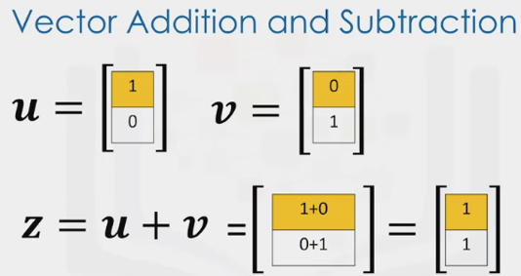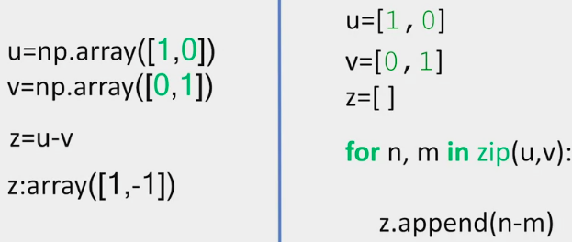

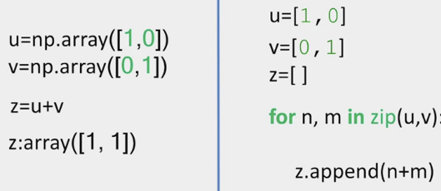

Left side is numpy, right side is python

1. Array and Multiplication with a Scalar

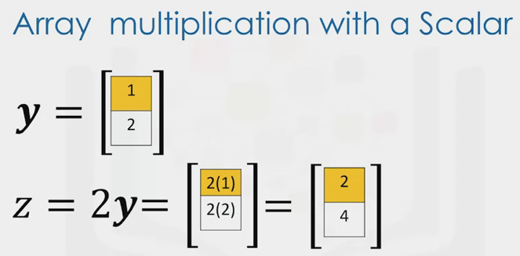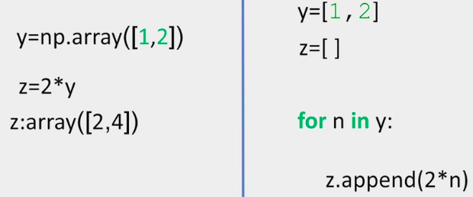

1. Product of two Numpy arrays

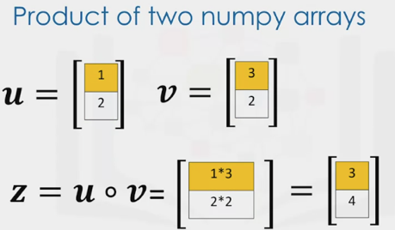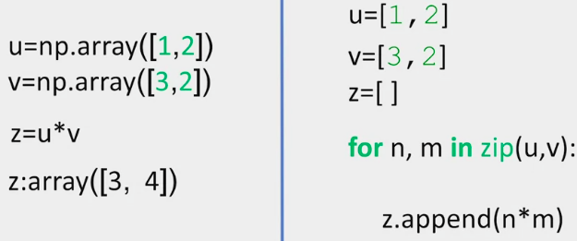

1. Dot Product: How similar two vectors are

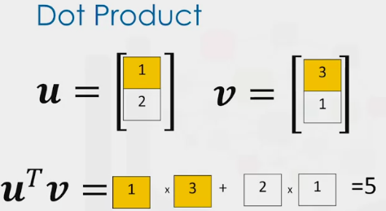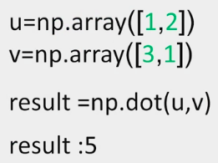

1. Broad-Casting

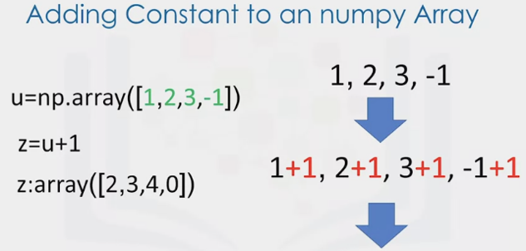

1. Universal Function – Function that operates on ND arrays

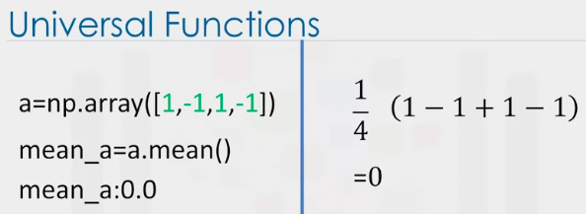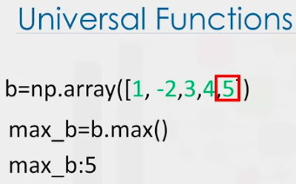

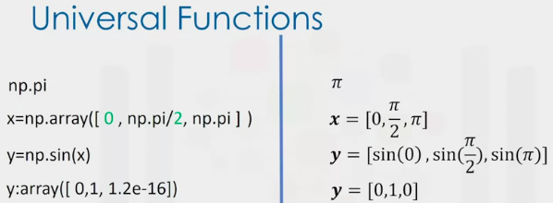

1. Np.linspace – Returns evenly spaced numbers over a specified interval

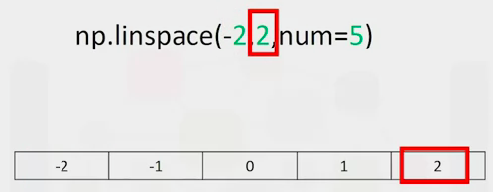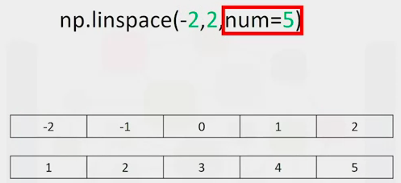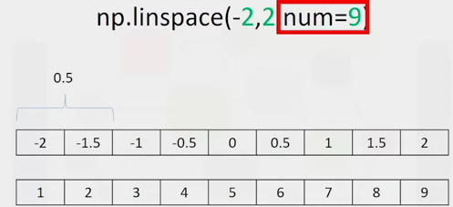

1. Plotting Mathematical functions
   1. First input corresponds to the x-axis
   2. Second input to the y axis

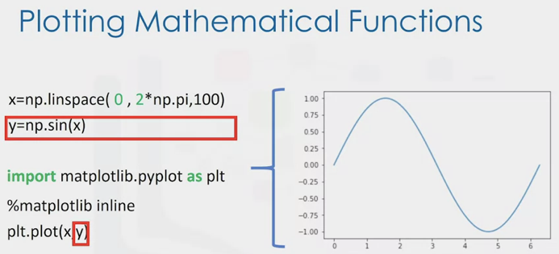

**Two Dimensional Numpy**

1. Nested Lists

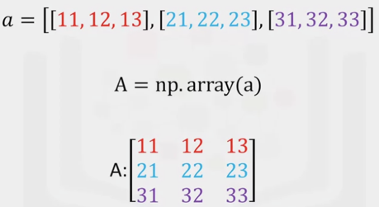 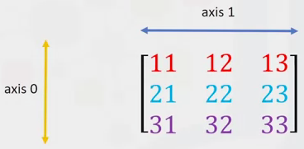

* 1. NDIM:2 (number of dimensions or axis’)

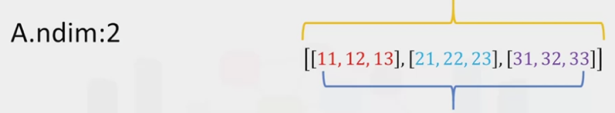

* 1. Shape: Number of rows and size of each of the nested lists

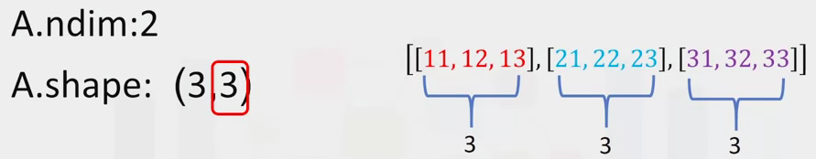

* 1. Size: Multiplying the number of rows and columns

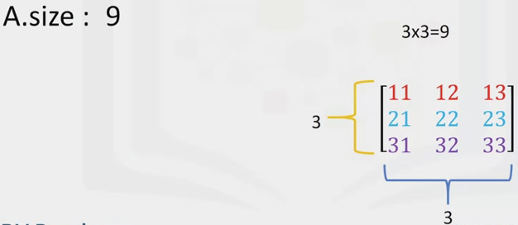

1. Indexing

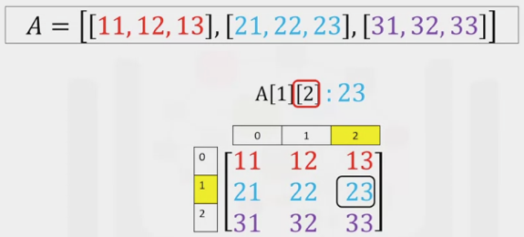

1. Slicing

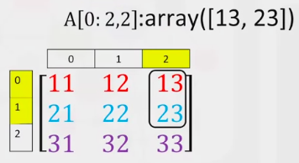

1. Matrix (adding arrays)

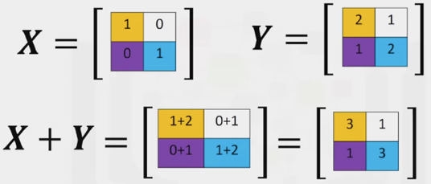 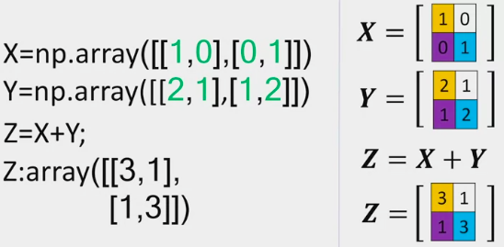

1. Multiplying an array by a Scalar

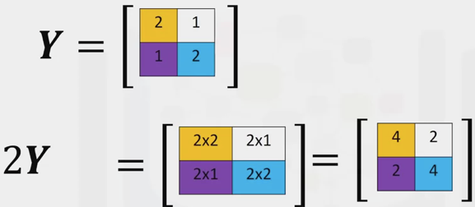 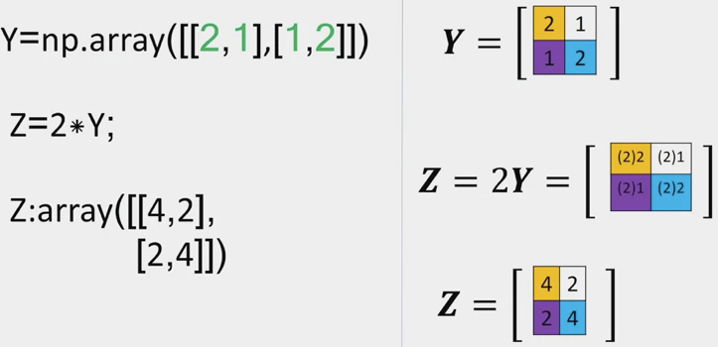

1. Hadamard Product

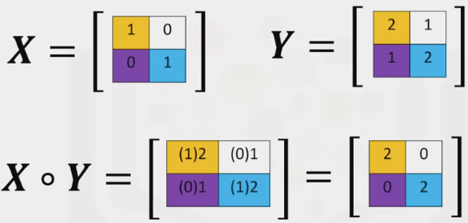 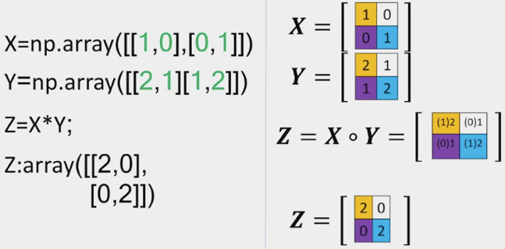

1. Matrix multiplication with Numpy arrays

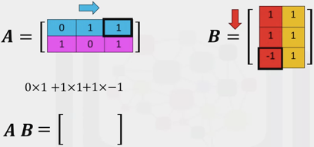 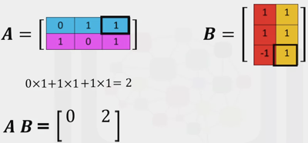 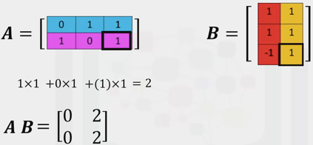

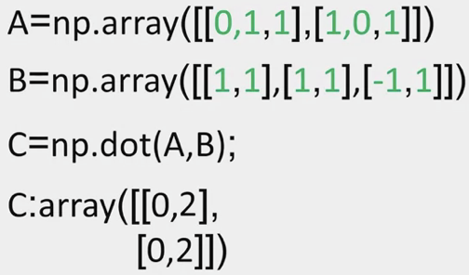

**WEEK 5 – SIMPLE API’S PART 1**

1. API: Application Program Interfaces
2. Allows two pieces of software communicate
3. Uses Pandas API to process the data

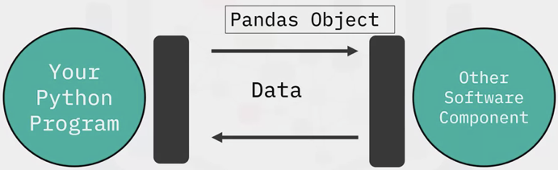

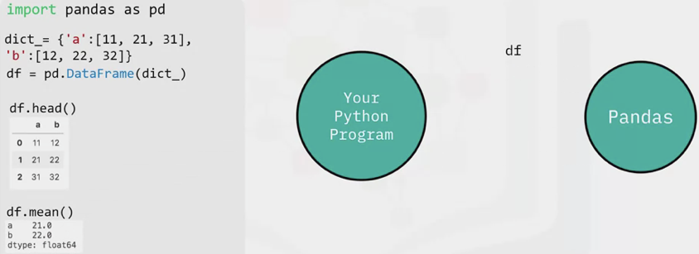

1. Pd.dataframe(dict_) = this is an instance
   1. Data in the dictionary is passed to the Pandas API
   2. The dataframe is then used to communicate with the API

Rest API’s

1. Representational State Transfer
2. Used to interact with web services

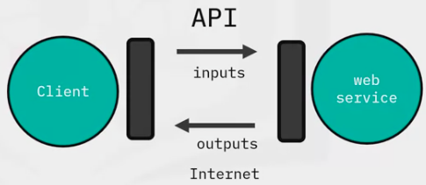

1. They have a set of rules regarding
   1. Communication
   2. Input or Request
   3. Output or response

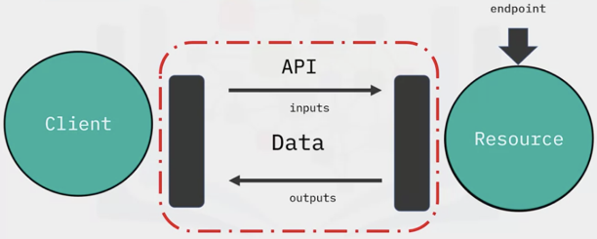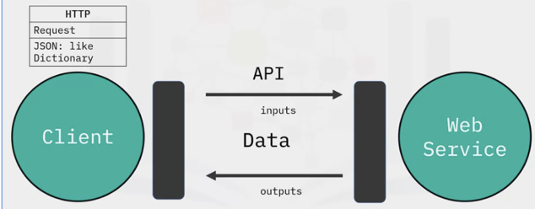

1. Client (you) sends a request as an http message containing a JSON file
2. The Web service performs the operation and sends an http message back

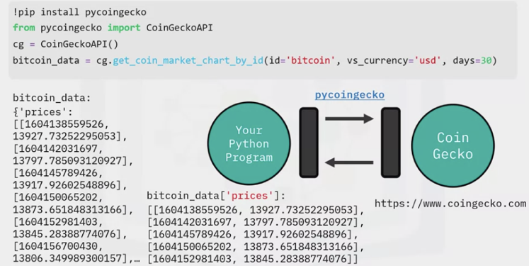

1. Install and import the library
2. Create a client object
3. Use a function to request the data
4. Response is a JSON file as a python dictionary in nested lists

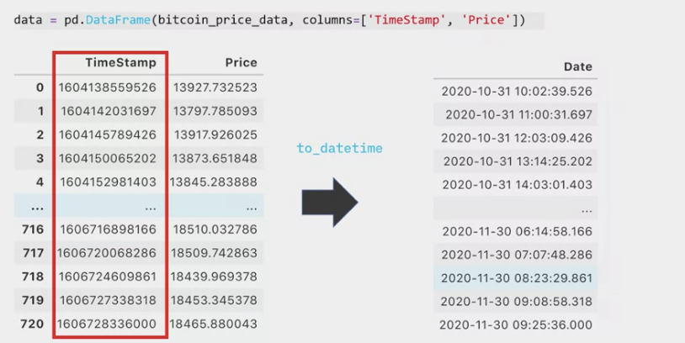

1. Convert nested list to a dataframe
2. To_datetime = pandas format to make the date and time readable

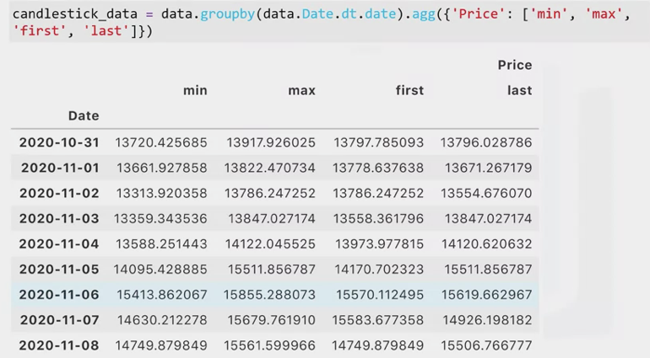

1. Prepare the data for a candlestick chart

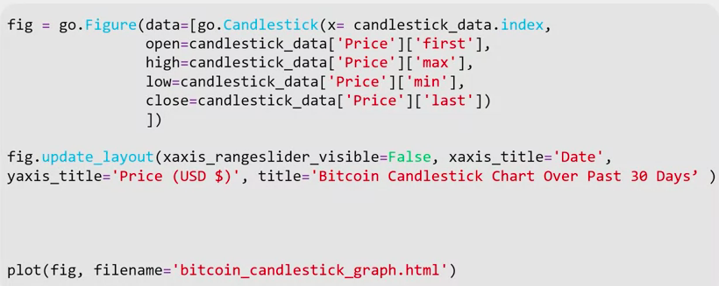

1. Use plotly to create the candlestick chart and plot it

REST API’S – PART 2

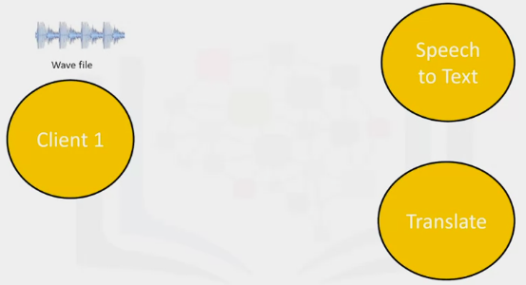 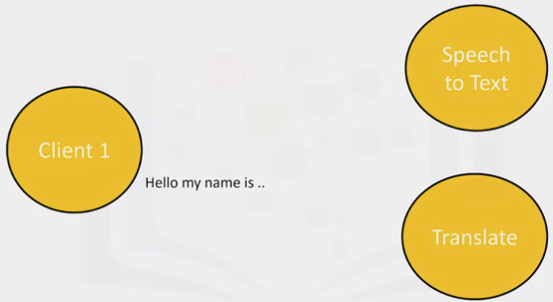

1. Transcribe an audio file to Watson speech to text API, then translate it

API KEYS and ENDPOINTS

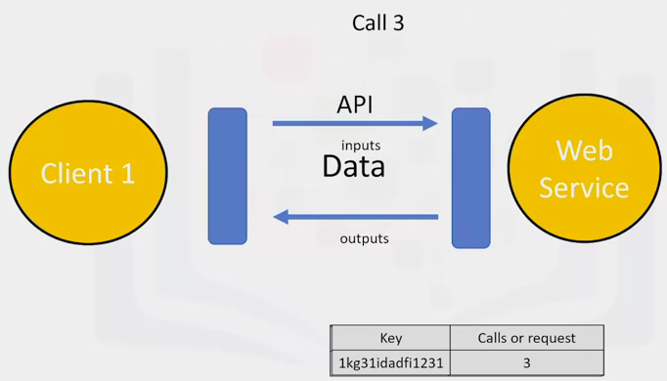

1. API key: Way to access the API. Unique set of characters the API uses to identify and authorize you
2. You may get charged for each call – so keep API key a secret
3. An endpoint is simply the location of the service – just like a web address

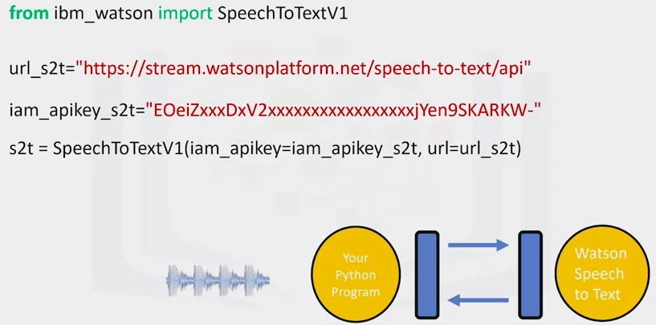

1. Download audio file into directory
2. Import SpeechtoTextV1 from IBM_Watson
3. The service endpoint is based on the location of the service instance (url)
4. Same applies for the API key
5. Create a speechtotext adapter object
   1. Parameters are the end point and API key

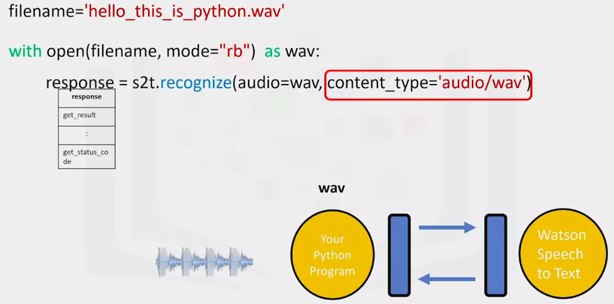

1. Filename = the path of the wav file we want to convert to text
2. Create file using “open” – set the mode to “rb”, which means to read the file in binary format
3. Use the method recognize from the speech to text adapter object
   1. Parameter “audio” is the file object
   2. Content_type is the audio file format
4. Service then sends a response in the object “response”

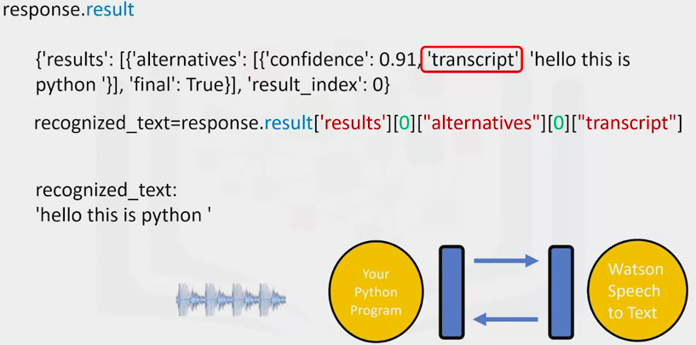

1. Attribute “result” contains a python dictionary
2. Interested in the key “transcript” and assign it to the variable recognized_text
3. Recognized_text now contains a string

Translate using Watson Language Translator

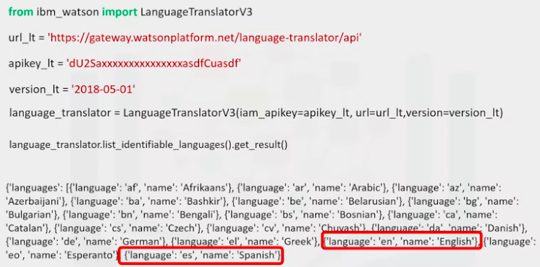

1. English = “en”/ Spanish = “es”

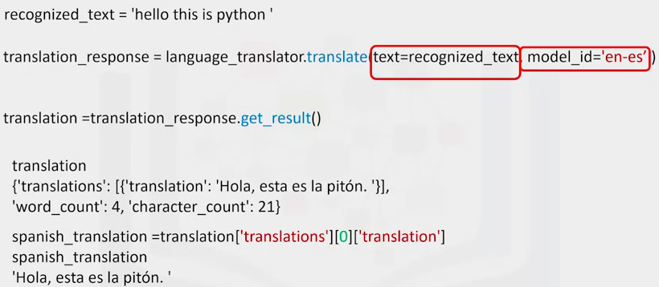

1. Use the method “translate”. Text is the object. Model_id is the model used
2. Method “get_result”()
3. Result is a dictionary – obtain the result with the string above

**REST API”S AND HTTP REQUESTS – PART 1**

1. URL: Uniform Resource Locator
   1. Scheme: The protocol, for this lab it will always be http://
   2. Internet address/Base URL: Used to find location (e.g. [www.ibm.com](http://www.ibm.com))
   3. Route: Location on the web server (e.g. /images/IDSNlogo.png.)

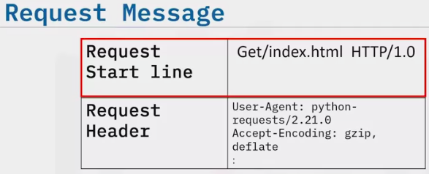 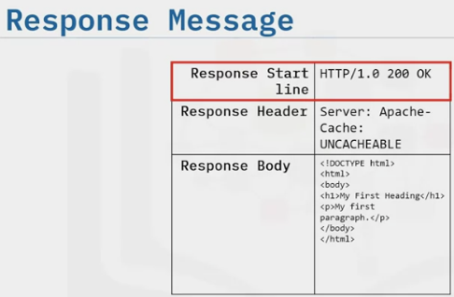

1. In the start line we have the “get” method
2. The response start line contains the version number followed by a descriptive phrase
   1. Status code 200: Means success
3. Response Boy containing the requested information

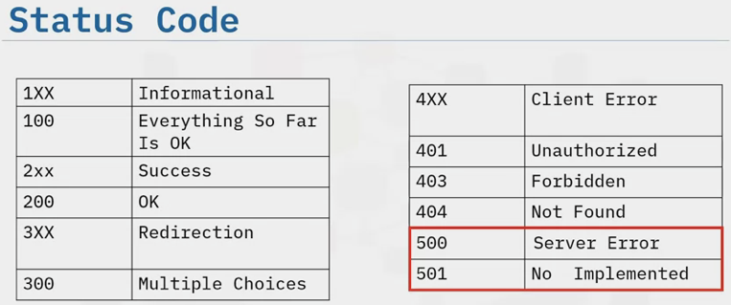 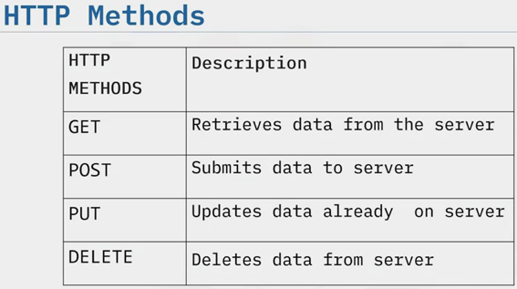

**PART 2**

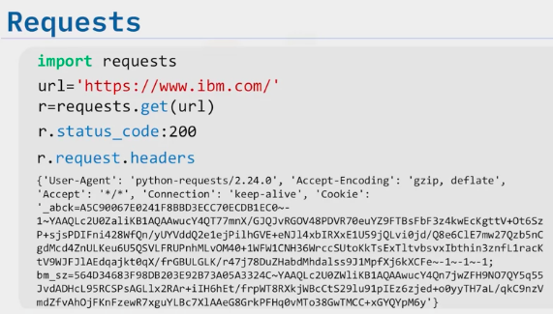 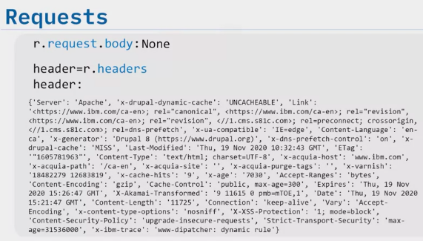

1. You can make a get request using the “get” method
2. Response object “r” has information such as the status of the request

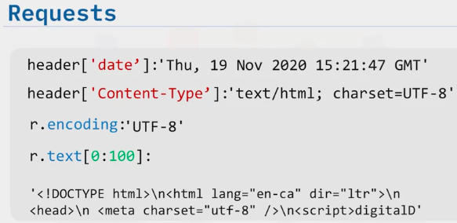

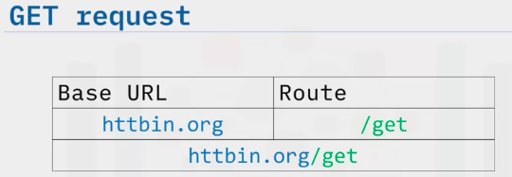

1. Get Request sent to the server

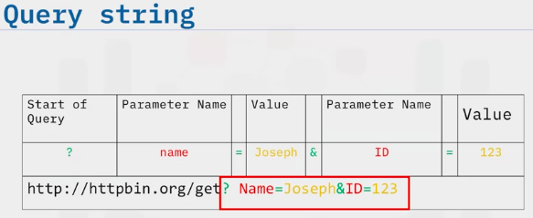

1. Query String: Part of URL and send other info to the webserver
   1. Start of the query is a question mark followed by a series of parameter and value pairs
   2. Name = Joseph. ID=123

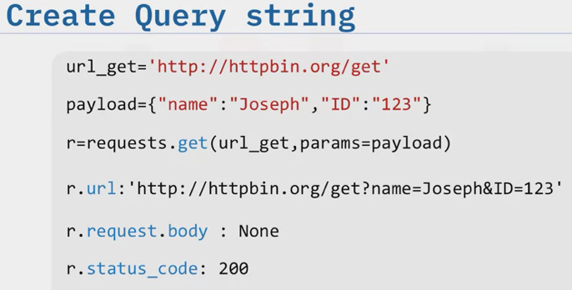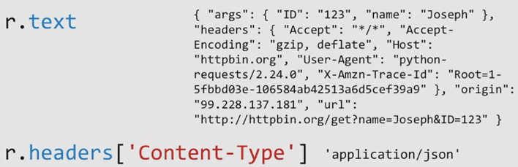

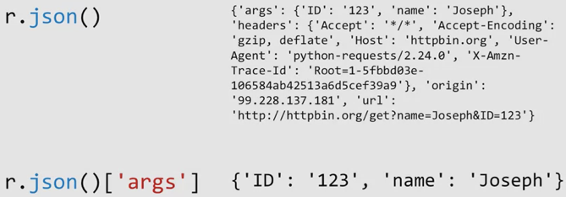

1. The key (‘args’) has the name and values for the query string

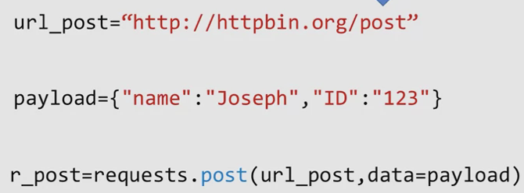

1. Post request: send data to a server in a request body, not the url

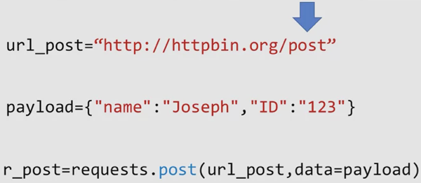

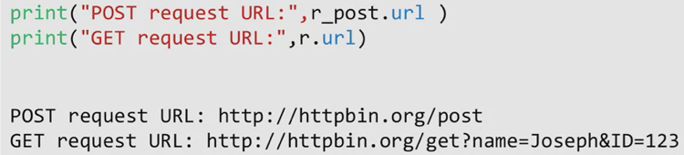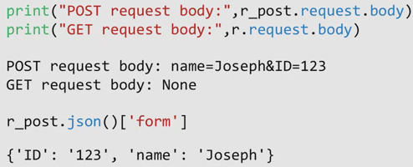

1. Only the post request has a body

**HTML FOR WEBSCRAPING**

1. HTML: Hyper text markup language

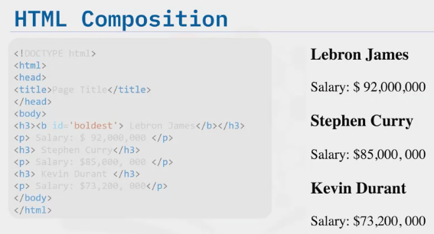

1. Page is comprised of HTML
   1. Elements enclosed in angle brackets called “tags”
   2. Tags tell the browser how to display the content
2. First portion contains the doctype html
   1. Head element contains metainformation about the html page
3. Body: What is displayed on the webpage
   1. H3 = type 3 heading (larger and bold)
   2. P = paragraph

HTML Tag

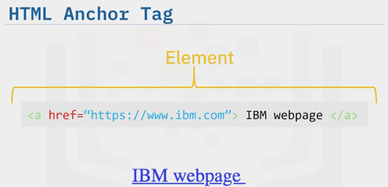 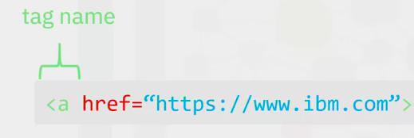

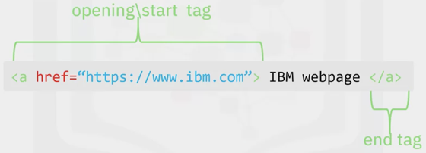 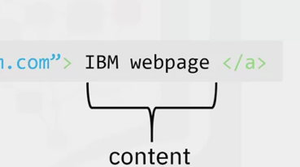 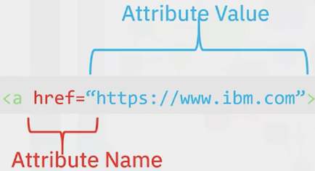

HTML Tags – think of like a tree

1. HTML
   1. Head (sibling)
      1. Title (child). 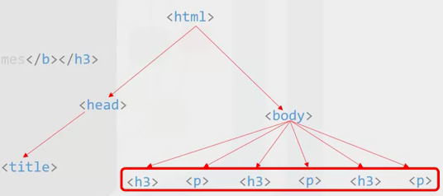
   2. Body (sibling)
      1. H and P tags (child).

HTML Table

1. Table Tag
2. TR = Table Row
3. TD = Table cell

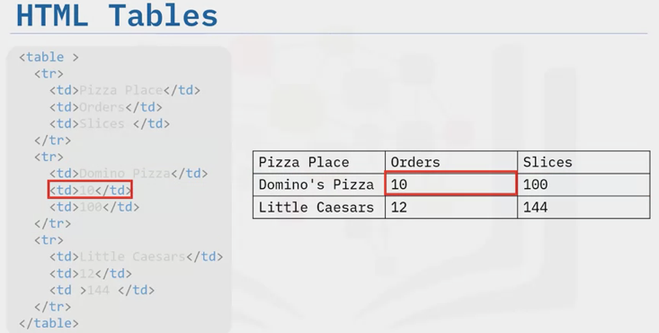

**Webscraping**

1. Process that can be used to automatically extract information from a website
   1. Python, Requests and Beautiful Soup

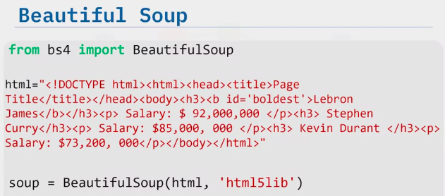

1. Import Beautiful Soup
2. Store the website as a string in the variable “html”
3. To parse it, pass it into the beautiful soup contructor
   1. “soup” represents the document as a nested data structure

Beautiful Soup

1. Represents html as a set of tree like objects with methods used to parse the html

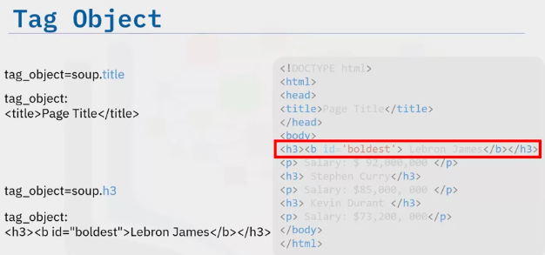

Use the tree representation to find the tag object

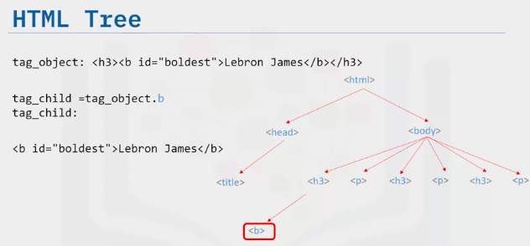

Navigate up the tree using the parent tag or sibling tag

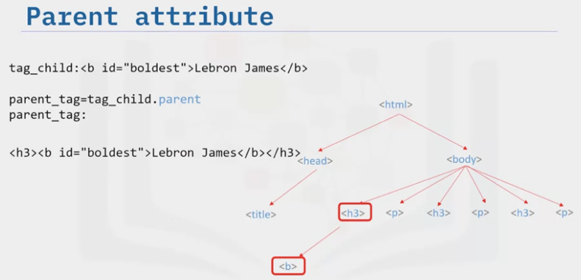

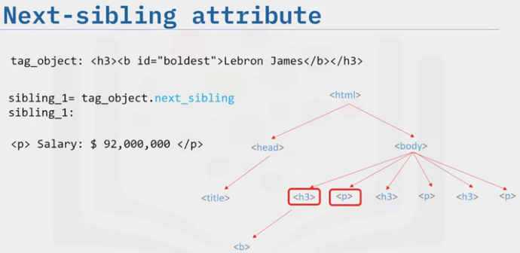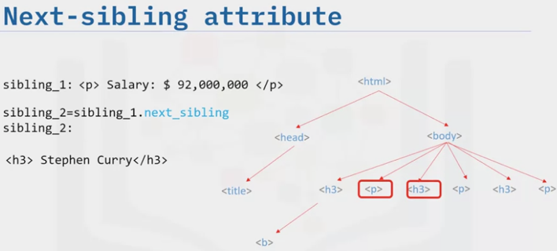

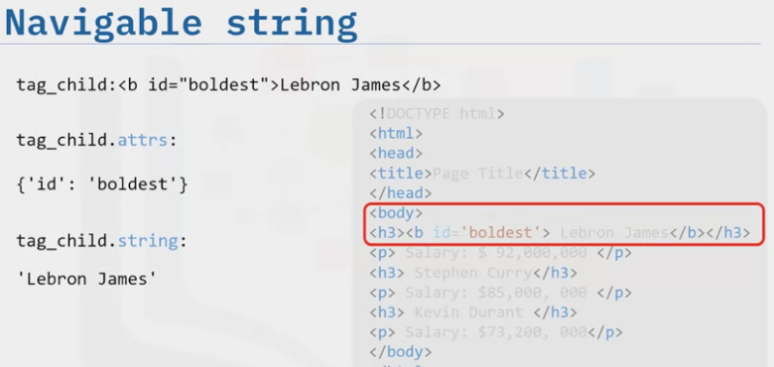

You can return the content as a navigable sting – like a python string that supports beautiful soup functionality

Find All

1. Filter: You can filter based on:
   1. A tags name
   2. Attributes
   3. Text of a string
   4. A combination of these

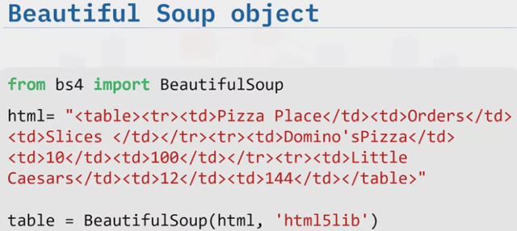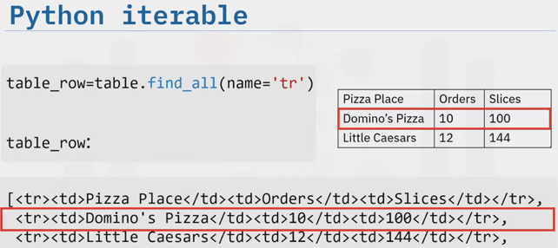

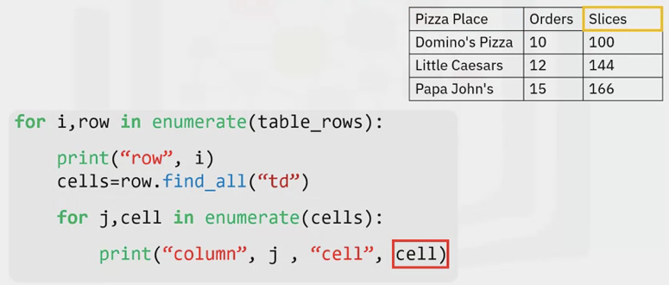

A WEBPAGE EXAMPLE

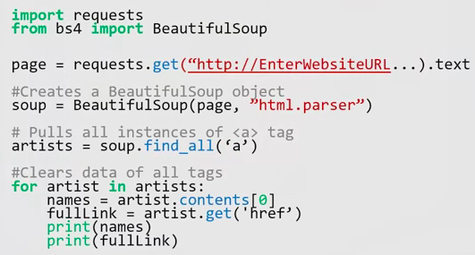

1. Import modules needed
2. Use the get method to download the webpage
   1. Input is the url – use the text attribute
3. Create a beautiful soup object

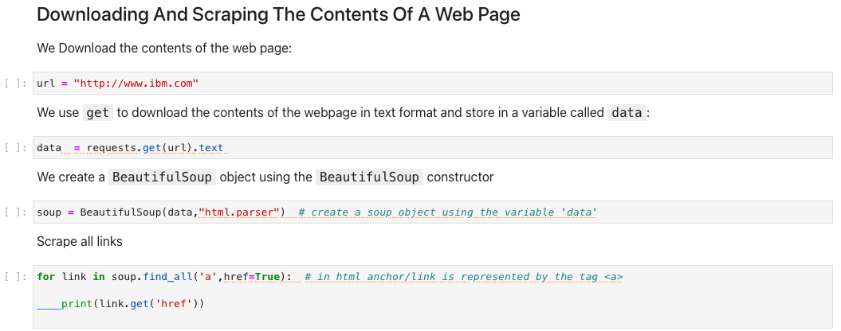  
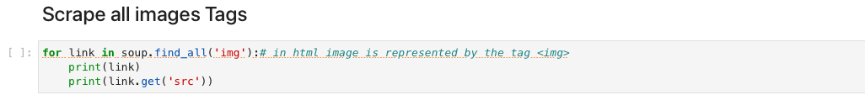

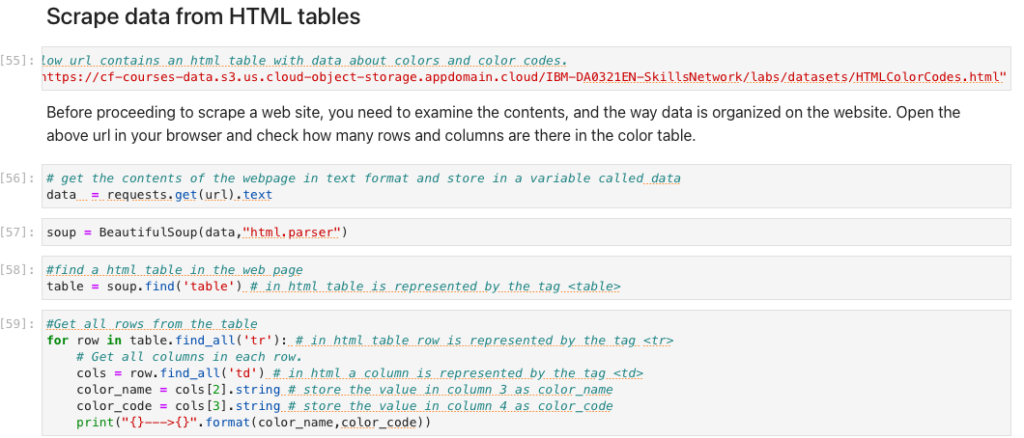

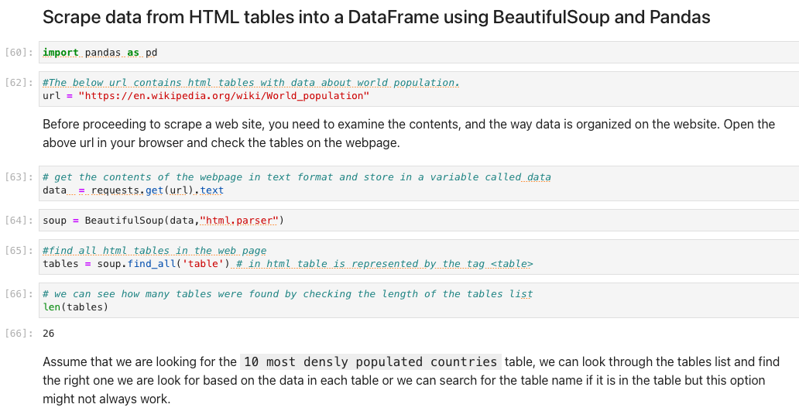

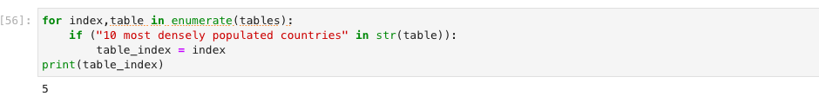

**Working With Different File Formats**

1. CSV
   1. Import pandas as pd
   2. Assign the file to a variable
   3. Create another variable to read the file with the help of the panda library

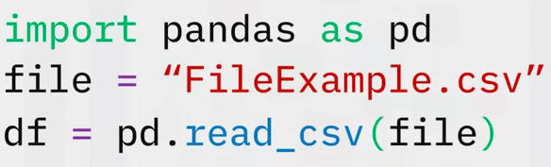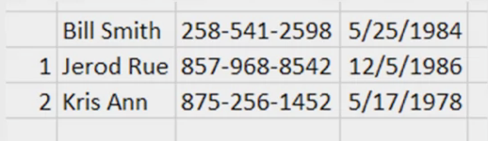

* 1. In this example there were no headers, so we create a header

1. Using Dataframes

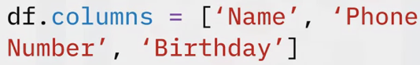 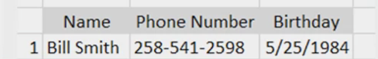

1. JSON
   1. Import JSON
   2. Add a line to open the file
   3. Call a load attribute to begin and read the file
   4. Print the file

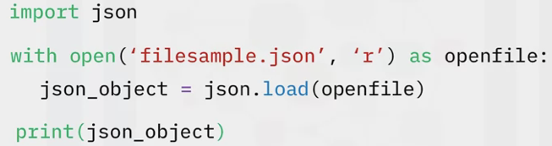

1. XML – Extensive Markup Language
   1. Import pandas
   2. Import xml.etree.ElementTree as etree
   3. Use “root” to parse the xml file
   4. Assign columns
   5. Create a loop to go through the data and append the dataframe

